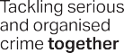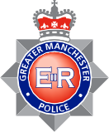

OPERATION CRANIUM
Operation Cranium aims to tackle the supply and distribution of illicit and counterfeit prescription medication across Greater
Manchester, the associated criminality around this type of crime, and those involved; both individuals and Organised Crime Groups.
The most common illicit drugs found include:

Diazepam Pregabalin
Xanex (Alprazolam) Zopiclone Tramadol
Possession of any of these are illegal without a prescription and are all classified as Class C drugs.

If you’re concerned someone is involved in the sale or supply of illegal prescription medication you can access many of our services online at www.gmp.police.uk.
For emergencies only call 999, or 101 if it’s a less urgent matter. Alternatively, you can contact Crimestoppers on 0800 555111.

