

**Breast Screening**

**Frequently Asked**

**Questions**



**South Lancashire Breast Screening Unit**

**Thomas Linacre Centre**

**Parsons Walk**

**E:BSUappointments@wwl.nhs.uk Wigan**

**T: 01942 774713 WN1 1RU**

Q. **Do I need a referral from my GP to be screened?**

A. No, if you are registered with a GP and are aged between 50yrs-70yrs you will be called automatically when we are next in your area.

**Q. I have lived away for 6 months and missed the mobile unit. Can I still be screened?**

A. Yes, just contact us when you return home.

**Q. Can I request breast screening when I am 50?**

A. No, if you are registered with a GP we will automatically send you an invitation when we next visit your area. This will be before your 53rd Birthday.

**Q. Can I be screened more regularly?**

A. The National Breast Screening Programme screens all women on a three-year cycle. If you have any symptoms or think you have a breast problem see your GP for advice.

**Q. My family has a history of breast cancer, I think I need screening more often.**

A. If you are worried about your risk of developing breast cancer your GP will be able to offer you more information about the family history Genetics Service.

**Q. I am the same age as my friend and she has received her invitation for breast screening. Why haven’t I had mine?**

A. Some women will be called when they are 50 but others will not receive their invitation until they are 52 depending on where they live. Everyone will have their invitation by their 53rd birthday.

**Q. I have just moved into the area, how do I arrange screening?**

A. Once you have registered with a GP we will be notified and will send you an invitation for breast screening once when we next screen that practice.

**Q. I am worried about my breasts, can I be screened?**

A. If you have any symptoms or think you may have a breast problem please see your GP for advice.

**Q. Can I choose where I am screened?**

A. We will try and give you as much choice as we are able to, depending where our mobile units are situated. Mobile units are sited at locations in the areas being screened.



**Q. Will the Mammographer be female?**

A. All our Mammographers are **female.**

It is very important to us that you feel comfortable throughout your screening appointment. We will do everything that we can to make sure that your privacy and dignity are respected during your visit.

**Q. I don’t have any lumps, do I still need to attend?**

A. Being breast aware and looking out for changes to your breast is a key part of detecting breast cancer early. However, mammograms can find small tumours that are in early stages of breast cancer before you can feel them, meaning treatment can start far sooner.

**Q. I’m afraid of what they might find**

A. Please don’t jump to conclusions. Most women get the all clear after breast screening. One in 20 will be called back for additional tests but being called back isn’t the same as a cancer diagnosis; it could just mean the original mammogram picture wasn’t satisfactory for the Consultant to report it and therefore has requested repeat images.

**Q. I can’t speak English; do you have information in other languages?**

A. We have leaflets in other languages explaining the process. Please contact the breast unit to obtain this information or access the Gov.uk website and search for “Breast screening: helping you decide” where you may download a copy in a language of your choice.

**Q. I have a learning disability, will I receive more information and support?**

A. All ladies with a learning disability are sent an appointment in the post with double the time slot of other ladies to ensure that we have more time to explain how things will work when you get here and you are welcome to bring a carer with you. The letters are sent in “Easy Read” format along with a leaflet explaining what happens at the appointment. If you require more information please contact the Patient Navigator at the South Lancashire Breast Screening Unit.

**Q. I’m too busy to attend for a mammogram**

A. Please make the time to attend for your breast screening appointment. The whole appointment lasts 15-20 minutes and the mammogram itself takes approximately 5 minutes. If the appointment time you have made is inconvenient, please phone call the breast unit and email to arrange a more suitable time.

**Q. Trans Man registered with a GP as a female**

A. If you are a trans man aged 50-70yrs who is registered with a GP as **female** you **will be** routinelyinvited for breast screening. We recommend you consider having breast screening if you have not had chest reconstruction or still have breast tissue.

If you are registered with your GP as a **male** you **will not** be invited for breast screening. If you have not had chest reconstruction we suggest you talk to your GP about screening. They can arrange a referral to a breast screening unit to have a mammogram

**Q. Trans Woman registered with a GP as male**

A. If you are a trans woman aged 50-70yrs who is registered with a GP a **male**, you **will not** be invited for breast screening. If you have been on long-term hormone therapy you may be at increased risk of developing breast cancer therefore we suggest that you speak to your GP who can refer you to a breast screening unit.

If you are registered with your GP as a **female**, you **will be** routinely invited for screening.



Please do not hesitate to contact the Patient Navigator at South Lancashire Breast Screening Unit if you have any further queries regarding the National Breast Screening Programme.

Telephone: 01942 774717 or 07858 492424

Email: janet.ellison@wwl.nhs.uk

**Please remember to be "Breast Aware" and check your breasts at least once a month**

[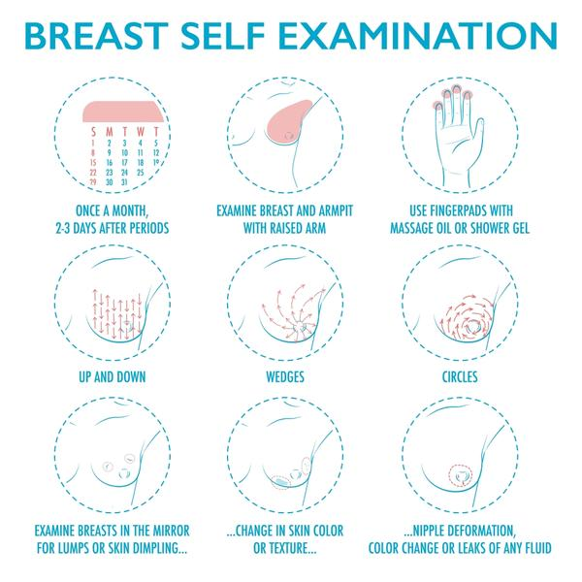](https://www.google.co.uk/url?sa=i&url=https%3A%2F%2Fclarycollection.com%2Fblogs%2Fnews%2Fhow-to-self-breast-exam&psig=AOvVaw3SEoy39QlvThlViLpHjGoi&ust=1612367088745000&source=images&cd=vfe&ved=0CAIQjRxqFwoTCIC50M7Fy-4CFQAAAAAdAAAAABAE)

**If you have any concerns or queries relating to breast symptoms, please speak to your GP for further advice**

**Q. Do I have to go to a mobile unit?**

A. We try to give appointments as close to your home as possible. If the mobile site is difficult for you, please phone us.

**Q. I suffer from cysts in the breast - Can I be screened more frequently?**

A. South Lancashire breast screening service screen eligible women once every three years. If you are concerned please see your GP for advice.

**Q. Is it painful?**

A. Some people find mammography painful and others find it uncomfortable, while other women hardly notice it. All women are different.

**Q. How long does it take to screen each breast?**

A Two images are required for each breast and takes a few seconds for each image obtained.

**Q. Does the compression cause any damage to the breast?**

A. There is no evidence to show that it does.

**Q. I missed my appointment – What should I do?**

A. Please contact the South Lancashire breast screening unit and we will be able to arrange another appointment for you if appropriate.

**Q. I have implants, can I have screening?**

A. Yes, please advise us **prior** to attending your appointment so that we can allocate a longer appointment slot to discuss the examination with you.

**Q. I have undergone reconstructive surgery, can I still be screened?**

A. This will depend on your reconstructive surgery and how much breast tissue still remains. We would advise you to contact us and to discuss further.

**Q. Can I be screened now I’m over 70yrs?**

A. If you are aged **over** 70, we will not automatically invite you for **breast screening**. However, you do have the right to be **screened** every three years if you ask. All you need to do is phone or write to your local **breast screening** unit to make an appointment.

**Q. Is it safe to attend during the Covid-19 Pandemic?**

A. We would like to re-assure all our patients that we are fully compliant with Covid-19 restrictions and safety measures to ensure that we protect both patients and staff.

Full details of Covid instructions are included with your invitation.