BOOTHSTOWN MEDICAL CENTRE

New Patient Registration CHILDREN

Please complete the GMS1 form and this confidential questionnaire for each child member of the family to be registered with the Practice).
Please complete in BLACK BIRO and BLOCK CAPITALS and tick the boxes as appropriate.
PROOF OF ID
Child’s birth certificate. Your photo ID, either passport or driving licence.
If you are newly arrived in this country, please bring your passport/visa to work form to confirm your date of birth

Full Name: | Date of Birth:
Gender: Male / Female (please circle) | NHS Number (if Known)
Address and Postcode | Home Telephone number
Address and Postcode | Mobile number
Previous Address and Postcode: | Next of Kin + relationship:
Previous Address and Postcode: | Next of Kin/emergency contact number:
NHS number (if known)
Mother’s Name:  Mother’s DOB:  Mother’s Address:  Email address  Registered at this practice: YES / NO | Father’s Name:  Father’s DOB:  Father’s Address:  Email address  Registered at this practice: YES /NO
Name of Parent /Guardian Registering Child | Who has parental responsibility
Previous Doctor’s Name & Address: | Previous Doctor’s Telephone Number:
Are there any vaccinations you do not want your child to have? Yes No
Please let us know which these are:

Immunisation website at www.nhs.uk

Child’s previous school (with address):

Are there any other adults living in the household?  If so please state their names: | Name ………………………………………………………………………  Name………………………………………………………………………  Name……………………………………………………………………..
Do you have a family Social Worker? | Yes Name…………………………………………………………  No

CHILDRENS IMMUNISATIONS
If your child is 0-5 yrs please provide us with information about any immunisations your child has received. If you are not sure which vaccinations you child has had, it would be helpful to bring along any records
(eg. the child health RED BOOK) when you next come to the surgery.

Age Due | Vaccine | Tick if Given | Date Given | At a GP Surgery | At Other Place
Birth onward | BCG  Hepatitis B (course of 4 injections  at birth, 1, 2 and 6 months)
8 weeks | 1st DTP & Hib & Polio  Pneumococcal  1st Meningitis B  1st Rotavirus
3 months | 2nd DTP & Hib & Polio  1st Meningitis C  2nd Rotavirus
4 months | 3rd DTP & Hib & Polio  2nd Pneumococcal  2nd Men B
12 months | 1st MMR  Hib & Men C Booster  3rd Pneumococcal  Men B Booster
3yrs 4 months | Dip/Tet/Pertussis + Polio booster  MMR Booster
Approx 12 yrs | HPV
Approx 15 yrs | Tet/dip/polio booster  MEN ACWY

Your  Religion: | C of E | Catholic |  |  | Other Christian (state) |  | Buddhist |  | Hindu | Muslim
Your  Religion: | Sikh | Jewish |  |  | Jehovah’s Witness |  | No religion |  | Other religion (state)
Place and Country of Birth |  | Date of arrival in the UK (if applicable)
First Language |  |  |  |  |  |  | Please indicate if you require the use of an interpreter YES/NO
Your Medical Background:

What illnesses and When?
What operations and When?
Any medical problems at present? If so please inform us here
Please list any tablets, medicines or other treatments you are currently taking:
(incl. dose + frequency)
Are there any  serious diseases that affect your Parents, Brothers or Sisters  (tick all that apply) |  |  | Breast  Cancer | Heart Attack |  | Heart attack under age of 60 |  | Bowel Cancer
 |  |  | Diabetes |  |  | High Blood Pressure |  | Asthma |  |  | Stroke
 |  |  | Thyroid Disorder |  |  | Any other important Family Illness?

Specific Needs:

If you have difficulty with communication please inform the practice and we will make every effort to accommodate your needs. Please detail below any specific needs you have so the Practice can ensure they are identified and accommodated by taking the appropriate action:

Please state any Sensory Impairment
(i.e. Speech, Hearing, Sight):
Do you have an Assistance Dog
Please state any Physical disabilities you have:
Please state any Mental disabilities you have:
Please state any requirements you have to be able to access the Practice premises
Please state any Religious or Cultural needs:
Please state any specific nutritional requirements you have:
Please state any allergies and sensitivities you have:
Please state any phobias you have:
CARER INFORMATION | The Practice recognises that it is possible for a child or young person under 18 years old to be a Carer. Please indicate with a tick in the box if any of the following statements apply to your child.  My child provides a substantial amount of care to an adult. □  My child provides a substantial amount of care to a disabled child. □  I give permission for my child’s name to be entered on the practice carers register. □  Please sign  ………………………………………………………………….

Appointment reminders:

Boothstown Medical Centre now offers a text message service. If you consent to this service you will receive text messages from us reminding you that you have an upcoming appointment or informing you of important surgery news.

I consent to the surgery sending me Text Messages: YES / NO

The information you have provided will be kept in strictest confidence under the Data Protection Act

Parent or Guardian’s Signature: Date:

GP accepting patient onto list signature:

Summary Care Records
SCR are an electronic record of your child’s Medications and allergies that can be accessed (with your consent) in the event of an emergency (for example at an A&E Department). If you wish to opt out of having a SCR, please complete Option 1. Please see our website for more details regarding Summary Care Records.

MY INFORMATION SHARING OPTIONS

PLEASE COMPLETE ALL THREE SECTIONS (You are able to change your decision at any time)

Option 1 - Summary Care Record – My Emergency Care Summary
This will be used in emergency care. The record will contain essential information about any medicines you are taking, allergies you suffer from and any bad reactions to medicines you have had, to ensure those caring for you have enough information to treat you safely.

□ YES, I would like a Summary Care Record. Healthcare staff will ask your permission before they look at your record, except in certain circumstances for example if you are unconscious.
□ NO, I do not want a Summary Care Record.
-------------------------------------------------------------------------------------------------------------------------------------------------
Option 2 – Record Sharing

Sharing Out
Do you consent to Boothstown Medical Centre sharing your data with those who are directly involved with your care and using a compatible computer system?

□ YES, I consent to share data with other compatible computer system users involved in my care.
□ NO, I do not consent to share data recorded at Boothstown Medical Centre with other system users involved in my care.

Sharing in
Do you consent to Boothstown Medical Centre viewing any data recorded at other Health Care services that may care for you?

□ YES, I consent to Boothstown Medical Centre viewing data held by other Health Care organisations.
□ NO, I do not consent to share data recorded at other organisations with Boothstown Medical Centre.
-------------------------------------------------------------------------------------------------------------------------------------------------
Option 3 – Care.Data (Research)
This information is used to improve services provided by the NHS by collecting information about people’s health.

Please see patient leaflet – Your Data Matters to the NHS – Appendix A

ETHNIC GROUP:
This surgery, in line with other health care providers, collects information about the Ethnic origin of patients. This information can help us to meet the needs of the community and ensure that all our patients have equal access to the health care the practice provides.
Please note that we are not asking about citizenship or nationality but about the ethnic group to which you feel you belong. All the information we receive will be treated with the strictest confidence. It will not be used for any other purpose and will not be revealed to anyone outside the surgery.
Please complete the form below by ticking the box with the ethnic group you feel you belong to. If you are descended from more than one group, please tick the one you feel you most belong to, or chose the “any other ethnic group” option.

A White | British
B White | Irish
C White | Any other white background
D Mixed | White and Caribbean
E Mixed | White and Black African
F Mixed | White and Asian
G Mixed | Any other mixed background
H Asian or Asian British | Indian
J Asian or Asian British | Pakistani
K Asian or Asian British | Bangladeshi
L Asian or Asian British | Any other Asian background
M Black or Black British | Caribbean
N Black or Black British | African
P Black or Black British | Any other black background
R Other ethnic groups | Chinese
S Other ethnic groups | Any other ethnic group
T First language

Thank you for completing this form
For more information about the services we offer, please refer to your new patient pack
or see our website:www.boothstownmedicalcentre.co.uk

STAFF USE ONLY:

GMS1 Completed Y N

Birth Cert & ID Verified Y N

Summarise Urgently Y N
Staff
Initial
Adult Registering Child has Parental Responsibility? Y N

Child under 5 – Details passed to HV Team Y N

COMMUNITY HEALTH SERVICES – CHILDREN’S
HEALTH VISITING & SCHOOL NURSING LIAISON

New registration for children 0 – 19 years within the practice

Dear Parent / Carer / Guardian Date:

Please complete the following details about your family and leave this information at reception. Information will be shared with the Health Visitor (for pre-school children) or the School Nursing service
(if school age).

Parent/s name ………………...…………………………………………………………………………………

New Address …..………………………………………….  ……………………………………………………………....  ……………………………………………………………….  ………………………………………………………………. | Previous Address…………..………………..…………  …………………………………………………………….  …………………………………………………..………  ……………………………………………..……………

Tel No: (Home) ………………………………... ….. Work . ………………………………….…….…….

Previous GP / Base ……………………………………………………………………………………..….………...

Previous Health Visitor / Base …………………………………………………………..……….

Child 1 ……………………………… DOB: …………… School attends: ………………………..…………….…..

Child 2 ……………………………… DOB: …………… School attends: …………………………………………..

Child 3 ……………………………… DOB: …………… School attends: …………………………..…….………..

Registering with GP Name …………………………………………………………………………...…………………

ADMIN - PLEASE E-MAIL TO APPROPRIATE HEALTH VISITOR

Tear off slip for parents

Health Visitor Contact is: Susan Burns (Wigan) based at Tyldesley Clinic
Tel: 01942 481018
e-mail: susan.burns12@nhs.net

Tina Grannell (Salford) based at Walkden Clinic
Tel: 0161 206 2085
e-mail: Tina.Grannell@srft.nhs.uk

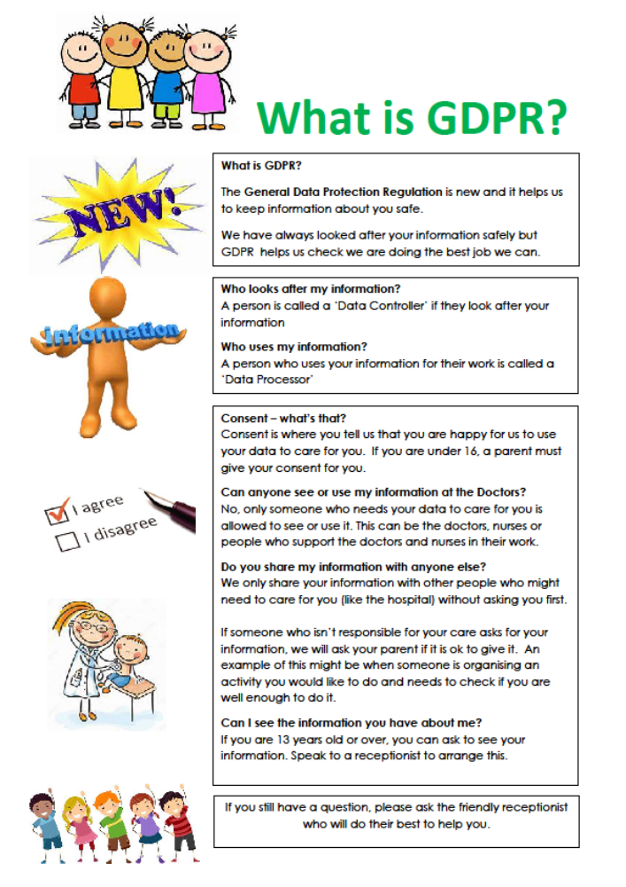

APPENDIX A



